REPORT TO | ON
Governance Committee | 14 March 2019
TITLE |  | REPORT OF
Internal Audit Plan 2019/20 |  | Interim Head of Shared Assurance Services

Is this report confidential? | No

- PURPOSE OF THE REPORT

1.1 To appraise members of the revised approach to Audit Planning for the 2019/20 year.

1.2 To seek the Governance Committee’s approval of the Internal Audit Plan for the 3 month period April to June 2019, in line with the revised methodology

- RECOMMENDATIONS

2.1 That the Committee:-

- notes the revised methodology;
- reviews and approves the Draft Internal Audit 2019/20 Plan for the period April to June 2019.

- CORPORATE PRIORITIES

The report relates to the following corporate priorities: (tick all those applicable):

Excellence and Financial Sustainability | X
Health and Wellbeing

Place

Projects relating to People in the Corporate Plan:

People

- BACKGROUND TO THE REPORT
4.1 Internal Audit activity within Local Authorities is mandated by the Accounts & Audit Regulations 2015, which require that the:-

…relevant authority must undertake an effective internal audit to evaluate the effectiveness of its risk management, control and governance processes, taking into account public sector internal auditing standards or guidance.

The Public Sector Internal Audit Standards (PSIAS) are the mandated professional standards in place for internal audit in local government. The PSIAS sets out the requirement for the Head of Audit & Assurance to:-

- develop a risk based audit plan;
- consult with Leadership Team and the Governance Committee; and

Obtain an understanding of the Council’s:-

- strategies;
- key business objectives;
- associated risks; and

6. PROPOSALS
6.1 Revised Methodology for Audit Plan
6.1.1 The PSIAS further states that the Head of Audit and Assurance must review and adjust the plan, as necessary, in response to changes in the Council’s business, risks, operations, programmes, systems and controls. In order to meet this requirement for 2019/20, a more flexible approach to the Audit Planning process and the resulting plan, has been utilised.
6.1.2 The flexible approach involves the provision of an initial 3 month Audit Plan for 2019/20 for the period April to June 2019; this will ensure that the current Governance Committee can agree and approve the proposed Audit Work during the initial period of the financial year; at the meeting in June a report will be provided looking back on the actual work undertaken in the period and providing a further 6 month plan for the Governance Committee to agree and approve. This will allow the reviewing and adjustment of the plan in response to changes in the Council’s risks, operations, programmes, systems and controls.
6.1.3 The Council has approved a full and robust Corporate Plan which has resulted in a number of Projects to support and there are a number of services being reviewed with a view to undertaking transformation; as the Council enters this significant period of change it is key to have a more flexible audit plan that can respond to changes and provide advice and support within these services without significantly impacting on resources as would happen with a more traditional plan.
    - The flexible approach will also allow sufficient time to explore other audit methodologies, such as utilising Data Analytic software, call IDEA, to undertake high risk key financial audit work which will reduce resource used in those areas whilst increasing coverage and being able to provide a more robust opinion.
    - The plan will subsequently be monitored throughout the financial year by the Leadership Team and the Governance Committee in order to ensure that the Head of Audit & Assurance can form an opinion on the Council’s overall control environment and report on it at the end of the financial year.
    - The Governance Committee are asked to note the methodology utilised.
6.2 Audit Plan

6.2.1 Internal Audit is an independent appraisal function whose prime objective is to evaluate and report on the adequacy of the Council’s system of governance, risk and internal control. This is largely achieved through an annual programme of reviews. The 2019/20 Internal Audit Plan for the period April to June 2019 is attached at Appendix 1 and contains the programme of reviews for the next financial year and is shown. This has been constructed following an assessment of audit need utilising a risk based approach which considers a number of factors including financial risk, legislative risk, reputational risk, changes in staffing, systems and procedures, the length of time since an area was last audited and items in the Corporate Plan and Corporate Risk Register. The Plan has been presented to Leadership Team.

6.2.2 The areas to be reviewed for the period April to June 2019 include areas of work that have been carried forward, either due to service areas requiring audit to be postponed due to internal review or not completed in the previous financial year for those reasons reported to Governance Committee in a separate report. There is also a major piece of work that is undertaken by Internal Audit in regard to the Annual Governance Statement; this involves the assessment of the Council’s Governance Framework, as it operated looking back at 2018/19, against the CIPFA / SOLACE requirements, identifying any areas of improvement which are included in an Action Plan for 2019/20 and reporting and monitoring these areas by Governance Committee.

6.2.3 A further piece of work included in the plan is to undertake an Assurance mapping exercise across the Council to identify where the Council gains assurance from other bodies or internally, such as Assurance Statement provided from Lancashire County Council in respect of the audit of Payroll, in order to ensure Internal Audit work is not duplicated; this will result in an overall view of where the Council already has processes in place to gain assurance to support both the Annual Governance Statement and the Internal Audit opinion of the overall control environment
6.3 Audit Days

6.3.1 The Internal Audit Plan for 2019/20 is based on an overall resource of 1,088 days excluding Annual Leave and Bank Holidays. This includes a combined 80 from Lancashire County Council and Merseyside Internal Audit Agency for IT Audit. Identified in the chart below is 800 actual audit days of which the outline is for 340 audit days each for South Ribble Borough Council and Chorley Borough Council. The remaining 120 days are available for the Shared Service.

6.3.2 The Chart below identifies the time allocation between Audits, Insurance and Emergency Planning. The remainder of the time is allocated to Planning, Monitoring and Reporting along with an element of staff time for Training and Development. 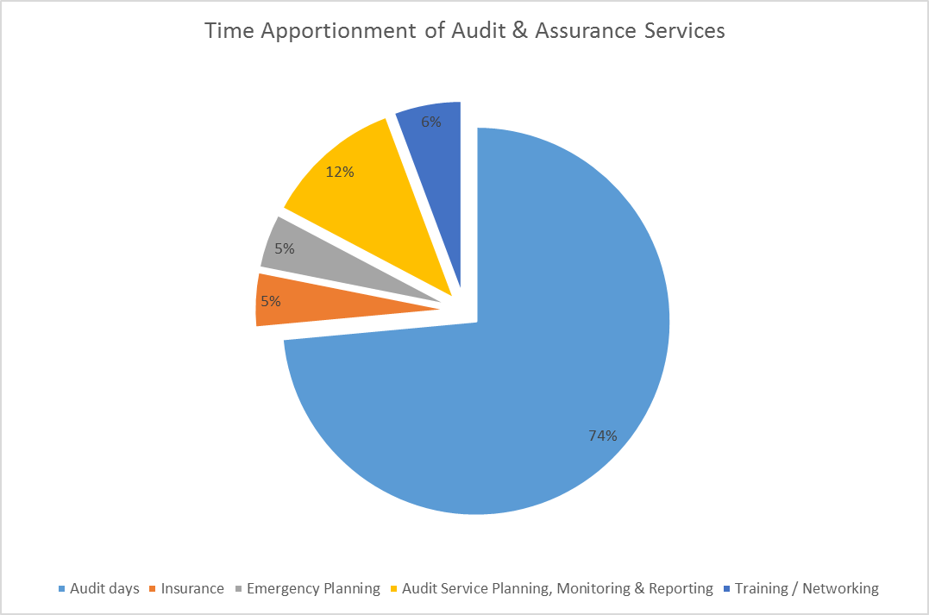
7. CONSULTATION CARRIED OUT AND OUTCOME OF CONSULTATION

7.1 Consultation with Leadership Team.

8. Financial implications

  - The Internal Audit and Assurance service will be delivered within the approved budget.

9. LEGAL IMPLICATIONS

  - If the Council failed to prepare and Audit Plan for 2019/20, there could be some legal challenge under the Accounts and Audit Regulations.

10. COMMENTS OF THE STATUTORY FINANCE OFFICER

10.1 To deliver more effective audit provision the Head of Shared Assurance is looking to utilise IT and our County allocations for different purposes than in prior years. For example we have carried out audits on all the prime financial systems every year when in fact they can tested less frequently which allows more time for transaction testing.

11. COMMENTS OF THE MONITORING OFFICER

  - There are no comments from the monitoring officer.

12. OTHER IMPLICATIONS:

- Risk | The failure to compile and agree a plan could result in legal and reputation harm resulting from non-compliance with the Accounts & Audit Regulations

13. BACKGROUND DOCUMENTS (or There are no background papers to this report)

List any background documents which are relevant, including policy documents or previous Cabinet reports. Remember for a public report all background documents referred to are open to public inspection on request. Use links to any web based documents.

14. APPENDICES (or There are no appendices to this report

Appendix 1 – Audit Plan 2019/20 for period April – June 2019

Tim Povall
Deputy CEO (Resources & Transformation)

Report Author: | Telephone: | Date:
Janice Bamber  Interim Head of Shared Assurance | 01772 625272 | 6 March 2019

